**INPUT**

Here when we speak something like Google (Fig.2 ) , then firstly our speech recognition system first listen it, and print listening, then recognize it, and print recognizing, and then it print Google as a user said and then execute it. Next figure (Fig.3 ) gives us output after execution.

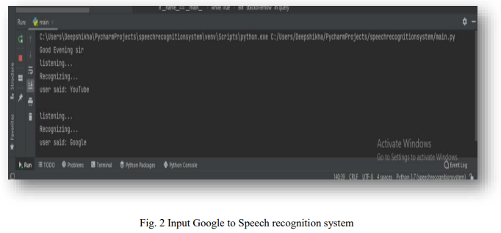

**OUTPUT**

After Recognizing Google, the model software execute and open Google as we shown in fig.

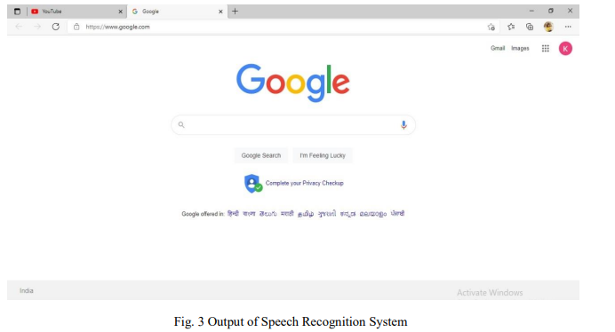

**INPUT**

Here when we speak something like Gmail (Fig. ) , then firstly our speech recognition system first listen it, and print listening, then recognize it, and print recognizing, and then it print open Gmail as a user said and then execute it. Next figure (Fig. ) gives us output after execution.

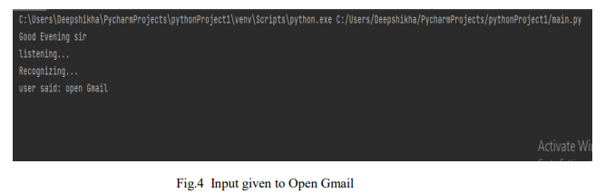

**OUTPUT**

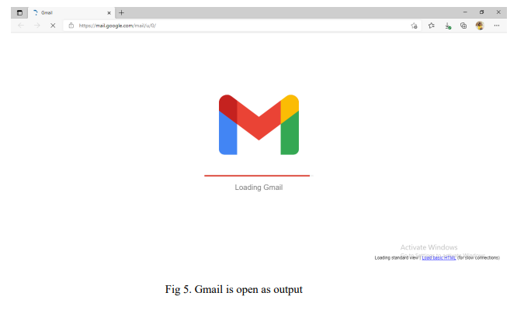After Recognizing Gmail, the model software execute and open Gmail as we shown in fig.